Donghyun (David) Seo

Carim-Sanni Sobur

Eric Luu

Radhanath Purakait

Shalih Miah

**Disposable TDCS “electrify your life”**

**Background**

Transcranial direct current stimulation (tDCS) can be an important tool for treating depression, increasing concentration at critical times, and adjusting mood and awareness. This is done generally by modulating neural connections. Though the effectiveness of tDCS is disputed, many find the treatment effective therapeutically. The design of new and convenient tDCS devices are useful to investigate for more potential uses of tDCS and the existing market of tDCS users.

The sponsor of this project has identified certain criteria that has not been meet in current tDCS devices in the market. Some of these criteria includes disposability and easy to use. The main goal is to create a tDCS device that comes in a ready to use package without requiring any prior setup and also easily disposable. Some examples of the possible users of this device would be surgeons who need a sterile device that can be disposed and doctors who would want to prescribe a one time treatment.

**Current Problem:** There are numerous tDCS devices in the market currently, but most devices are bulky and tedious to use. The implementation of a disposable device that is “straight out of the bag use” for professionals (military personnel, police officers, guards) or for a sessions on the go was proposed for this problem.

**Need Statement:** Need to find a way to make a low cost tDCS device that can be disposed after a single dose (20~40 minutes).

**Prior Art**

**Iontopatch 80:**

This device is designed to pass drugs transdermally using electric current. The principle is that the electric current makes the skin more permeable to the drug in the saline solution. This seems irrelevant to tDCS, however the formfactor of the device, its packaging and its ease of use are ideal for a disposable tDCS. One element from this design we want to take is the use of a small battery (or other energy storage device), we like the idea that we can fit the power source and the circuitry into one unit. Additionally, the disposability of the device is something we should mirror and emulate. The current magnitude is in the correct range as tDCS, however we would need to regulate it better. Also we need to improve on the design for it to work on hair.

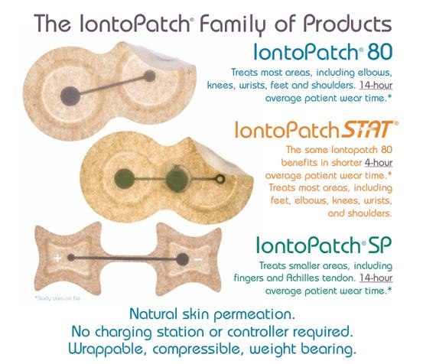

**Thync Device:**

Thync Device is one of the self-usable portable brain stimulation devices in market currently. Unlike its competitors, which use cranial electrotherapy or transcranial direct current stimulation (tDCS), Thync doesn’t directly target the brain. Instead, the triangular module applies pulsed electrical currents to the electrodes attached to it, targeting nerves on the face. It modulates some of the hormones underlying fight to fight response by ramping these hormones up or down. Thync claims to engender two effects – or “vibes”, in Thync parlance – calm or energy*.*

**Disadvantages**: The device is expensive, not disposable and its montages are restricted to the forehead + Neck and forehead + back of the ear.

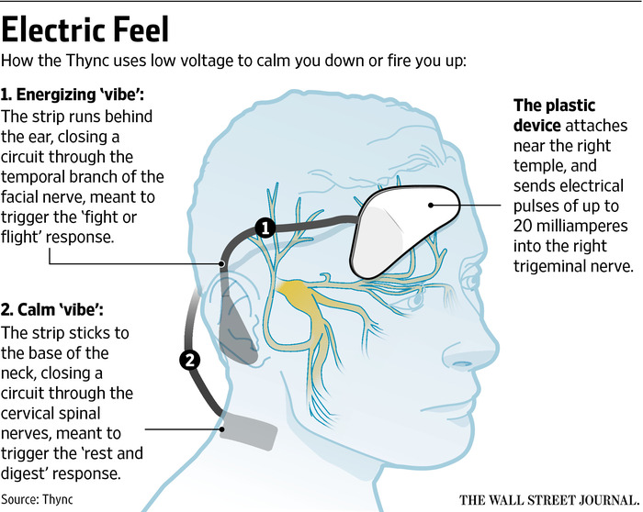

#### "Thync Device - Google Search." *Google.com*. N. p., 2018. Web. 11 Oct. 2018.

**The Brain Stimulator v3.0:**

The Brain Stimulator v3.0 is another example of a portable tDCS. The device features a push buttons which allow the user to increase and decrease the current flow, as well as shut off the device at any time. It has a Smart Current Ramping that creates smooth current transitions, providing for amazingly comfortable tDCS sessions. The precision components and streamlined circuitry allows the device to operate at the highest 2 milliamp setting for over 90 hours. It has a replaceable battery and has a 30-minute “set & forget” session timer.

**Disadvantages:**The device even though relatively cheap requires a bit expertise to set up. Electrode positioning also requires a bit of patient input which is prone to mistake.

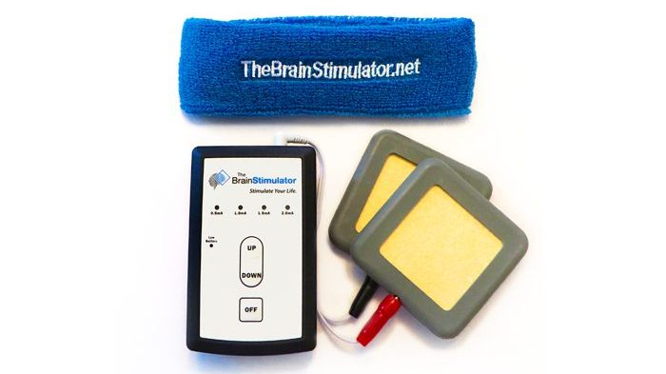

#### "The Brain Stimulator - Cranial Stimulation Devices." *The Brain Stimulator tDCS Devices*. N. p., 2018. Web. 16 Oct. 2018.

**Project Description Specifications**

1. Electrical Safety
   1. Current amplitude
   2. Electrode interactions
   3. Component selection/consistency
   4. Dosage
   5. Safety precautions
   6. Battery safety
   7. Contact quality and material: electrodes connected to the sponge. Use fasteners to tight it if needed.
   8. Ramp up and down current
2. Low cost and environmental safety
   1. This is a very cheap and easy to make device, as it only should costs 15 dollars or less.
   2. The materials that should be used range from resistors, potentiometer, batteries, wires, pcb board, nfc chip. All are low cost.
   3. The circuit should be enclosed with fabric, plastic, or special paper to be safe to handle.
   4. Circuit should be protected from moisture of electrodes in individual package
3. Ergonomics:
   1. One person should be able to operate the device.
   2. Device has an option for powering on/off.
   3. The wires connecting to the electrodes are long enough so that the user can place the device in his/her pocket.
   4. Device should be ready to go once opening.
   5. User should not have to think about pad placement and voltage. It should be hands free operation.
   6. Electrodes and cheap headgear needs to be designed for this device
4. Size and Weight Restrictions:
   1. Weight should not exceed 1 lbs.
   2. Length should not exceed 6 in.
   3. Width should not exceed 6 in.
   4. Height should not exceed 6 in.
   5. Should be able to be packaged in a simple plastic bag with electrode safely.
5. User Interface Design
   1. Buttons/controls: Power/Start button, buttons for each duration/power (current).
   2. Packages should be clearly labeled with current rating.
   3. The user should be able to pull the device out of the bag without safety precautions and be able to use it immediately.
   4. Device should be for specific application.
   5. Montage specification
6. “Stretch“ goals
   1. User changeable current
   2. Give user ability to change waveform.
   3. One important feature is sterilizability, if possible it should make the product stand out for uses in sterile environments like operation rooms (mentioned by sponsor).

**Intellectual property claims**

1. Device will be disposable
2. Device will be extremely easy to use
   1. Patient should be able to self administer the medication
3. Device will be sterilizable*
4. Device will come in easy to open packaging
5. Device should output a steady current of 2 mA or less depending on the type of device used
6. Headgear is easy to put on and use properly

* This aspect of the device may not be fulfilled in final design, however it is a goal

**Patents:**

**Headgear (Patent-** Flexible electrode position for universal application)

1. **Patent number: US8583238B1**
   1. It is a wearable apparatus that aims to be worn during sleep it is not disposable but it is designed for comfort and long term wear as well as usability. It is optimal for patients without hair.
   2. The main selling point is that this device is user operable
   3. 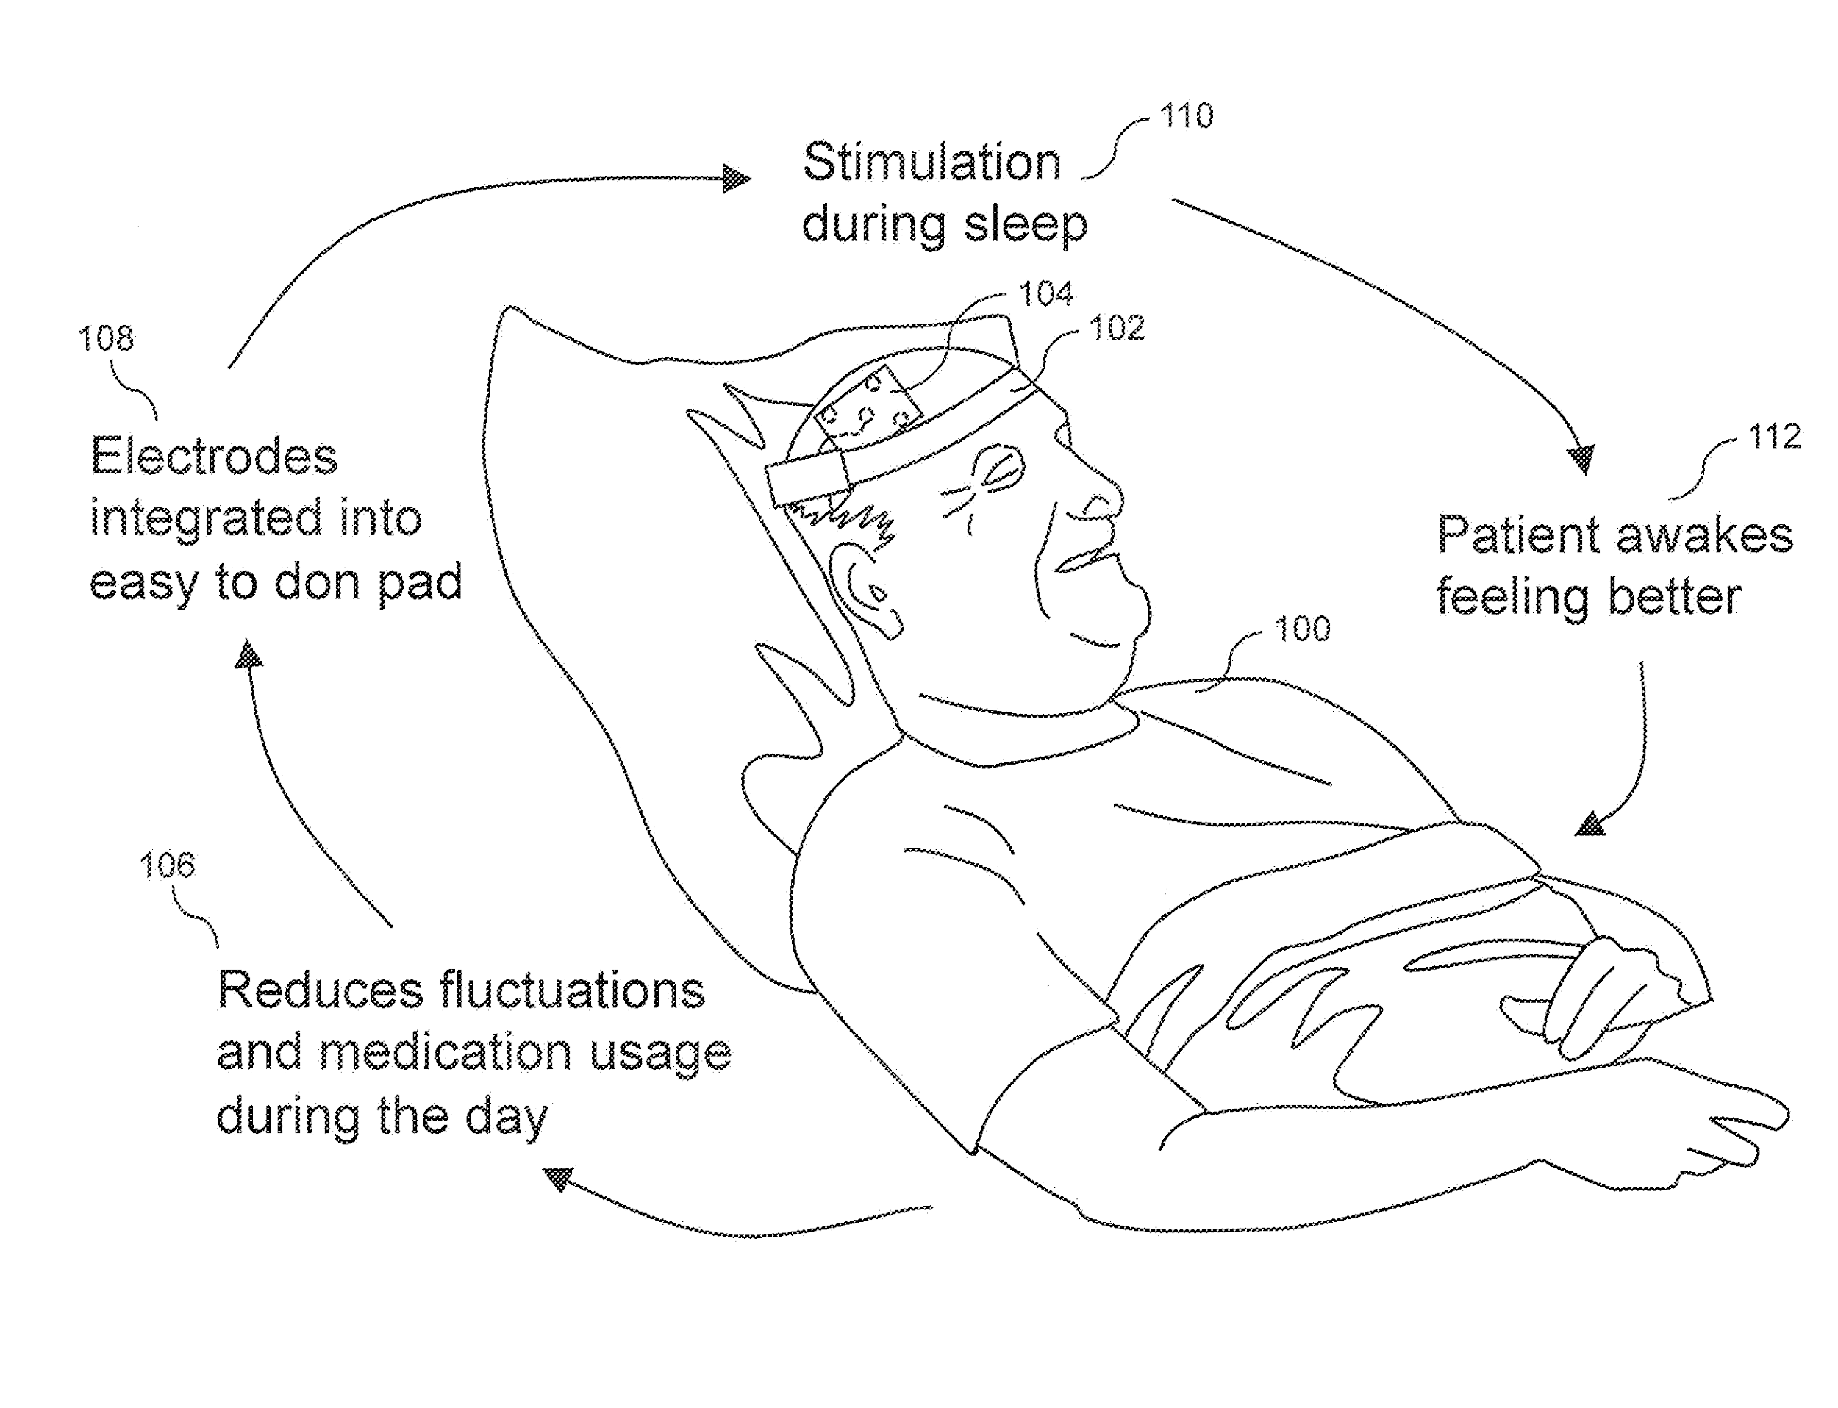
2. **Patent Number: US8239030B1** 
   1. This device utilizes a full headgear design, it is not cost effective however the design is flexible and could be used to design similarly disposable tdcs devices.
   2. 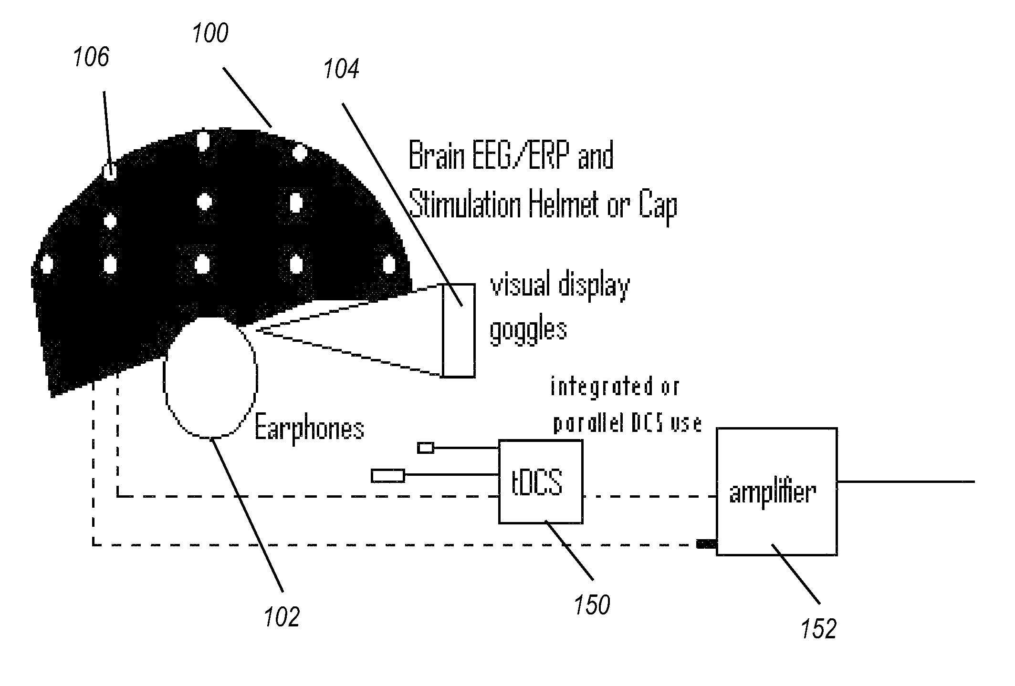
3. **Patent number: US20140257448**
4. Head wearable brain stimulating device (hat-like design).
5. It contains a pulse generator and two electrodes.
6. Place the patches on desired spots of the head scalp to send an electrical pulse to stimulate the desired part of the brain.
7. 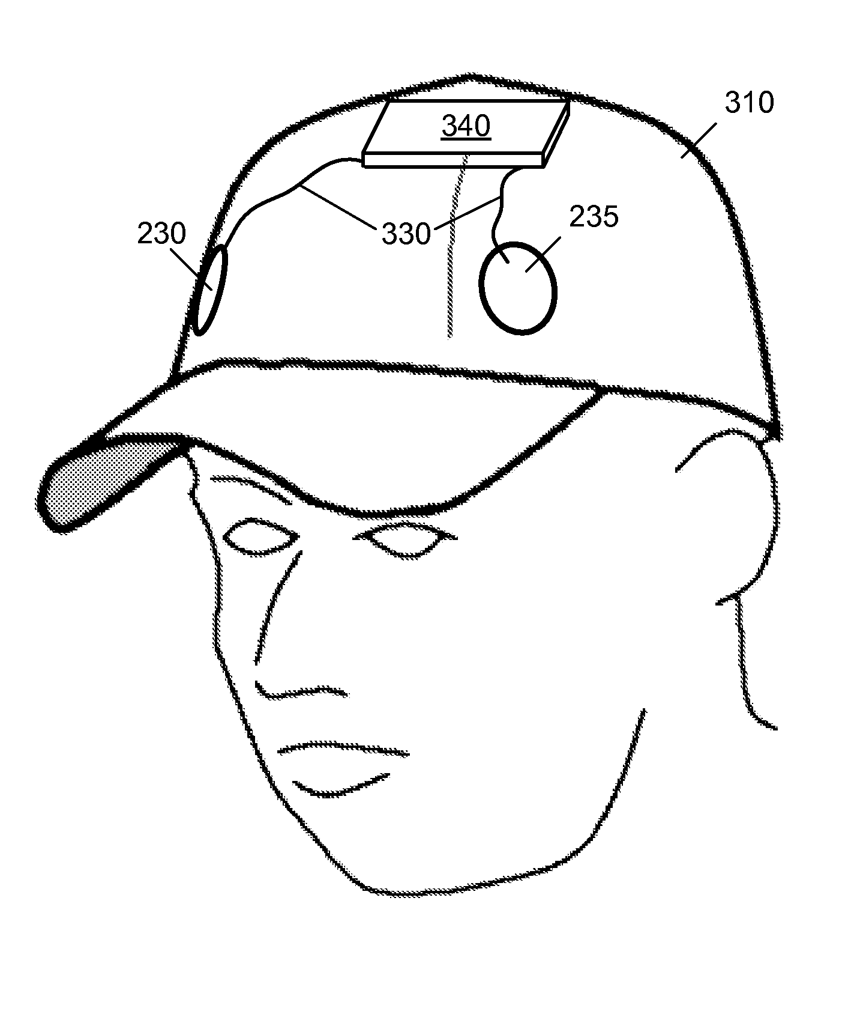

**Total device solutions**

1. **Patent number: US20080208287A1**
   1. Non-invasive device which uses two electrodes, one connected to the motor control region of the brain and one connected to a target body region to provide a treatment to neurological disorders.
   2. Treatments last between 20 to 40 minutes with a set electrical pulse at a frequency between 4 and 200 Hz.
   3. 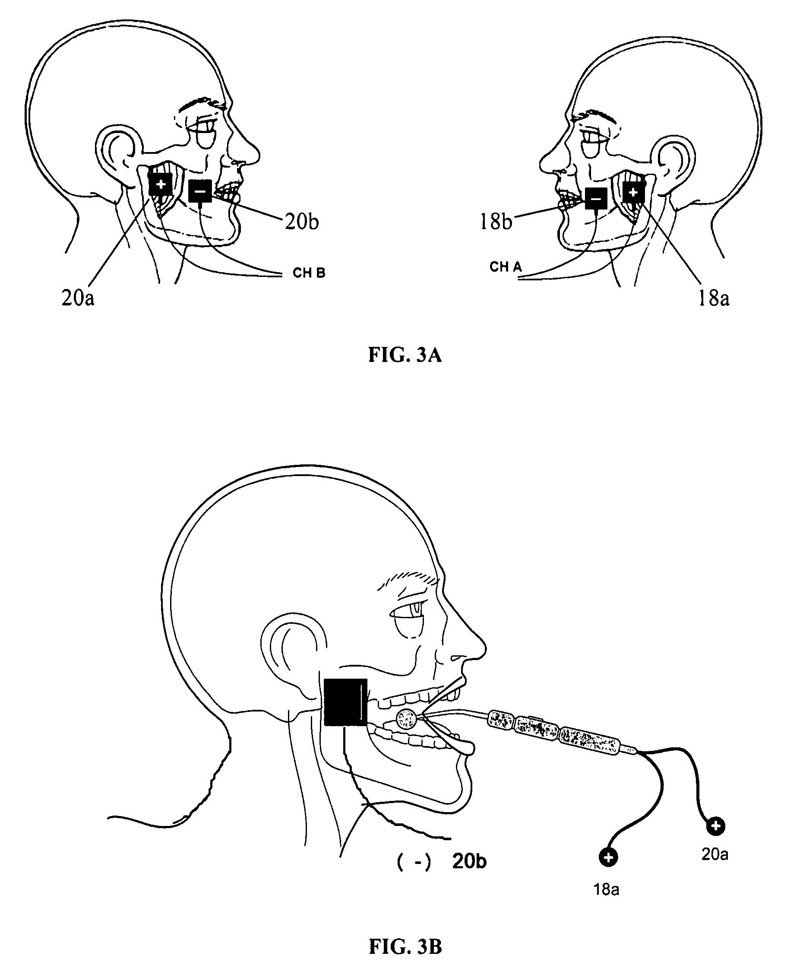
2. **Patent number: US20110288610A1**
   1. Mobile device that provides an auto transcranial stimulation that can be regulated and controlled.
   2. The device comprises of a transportable stimulation generator and a current generator with an accessible user interface for selecting different programs.
   3. 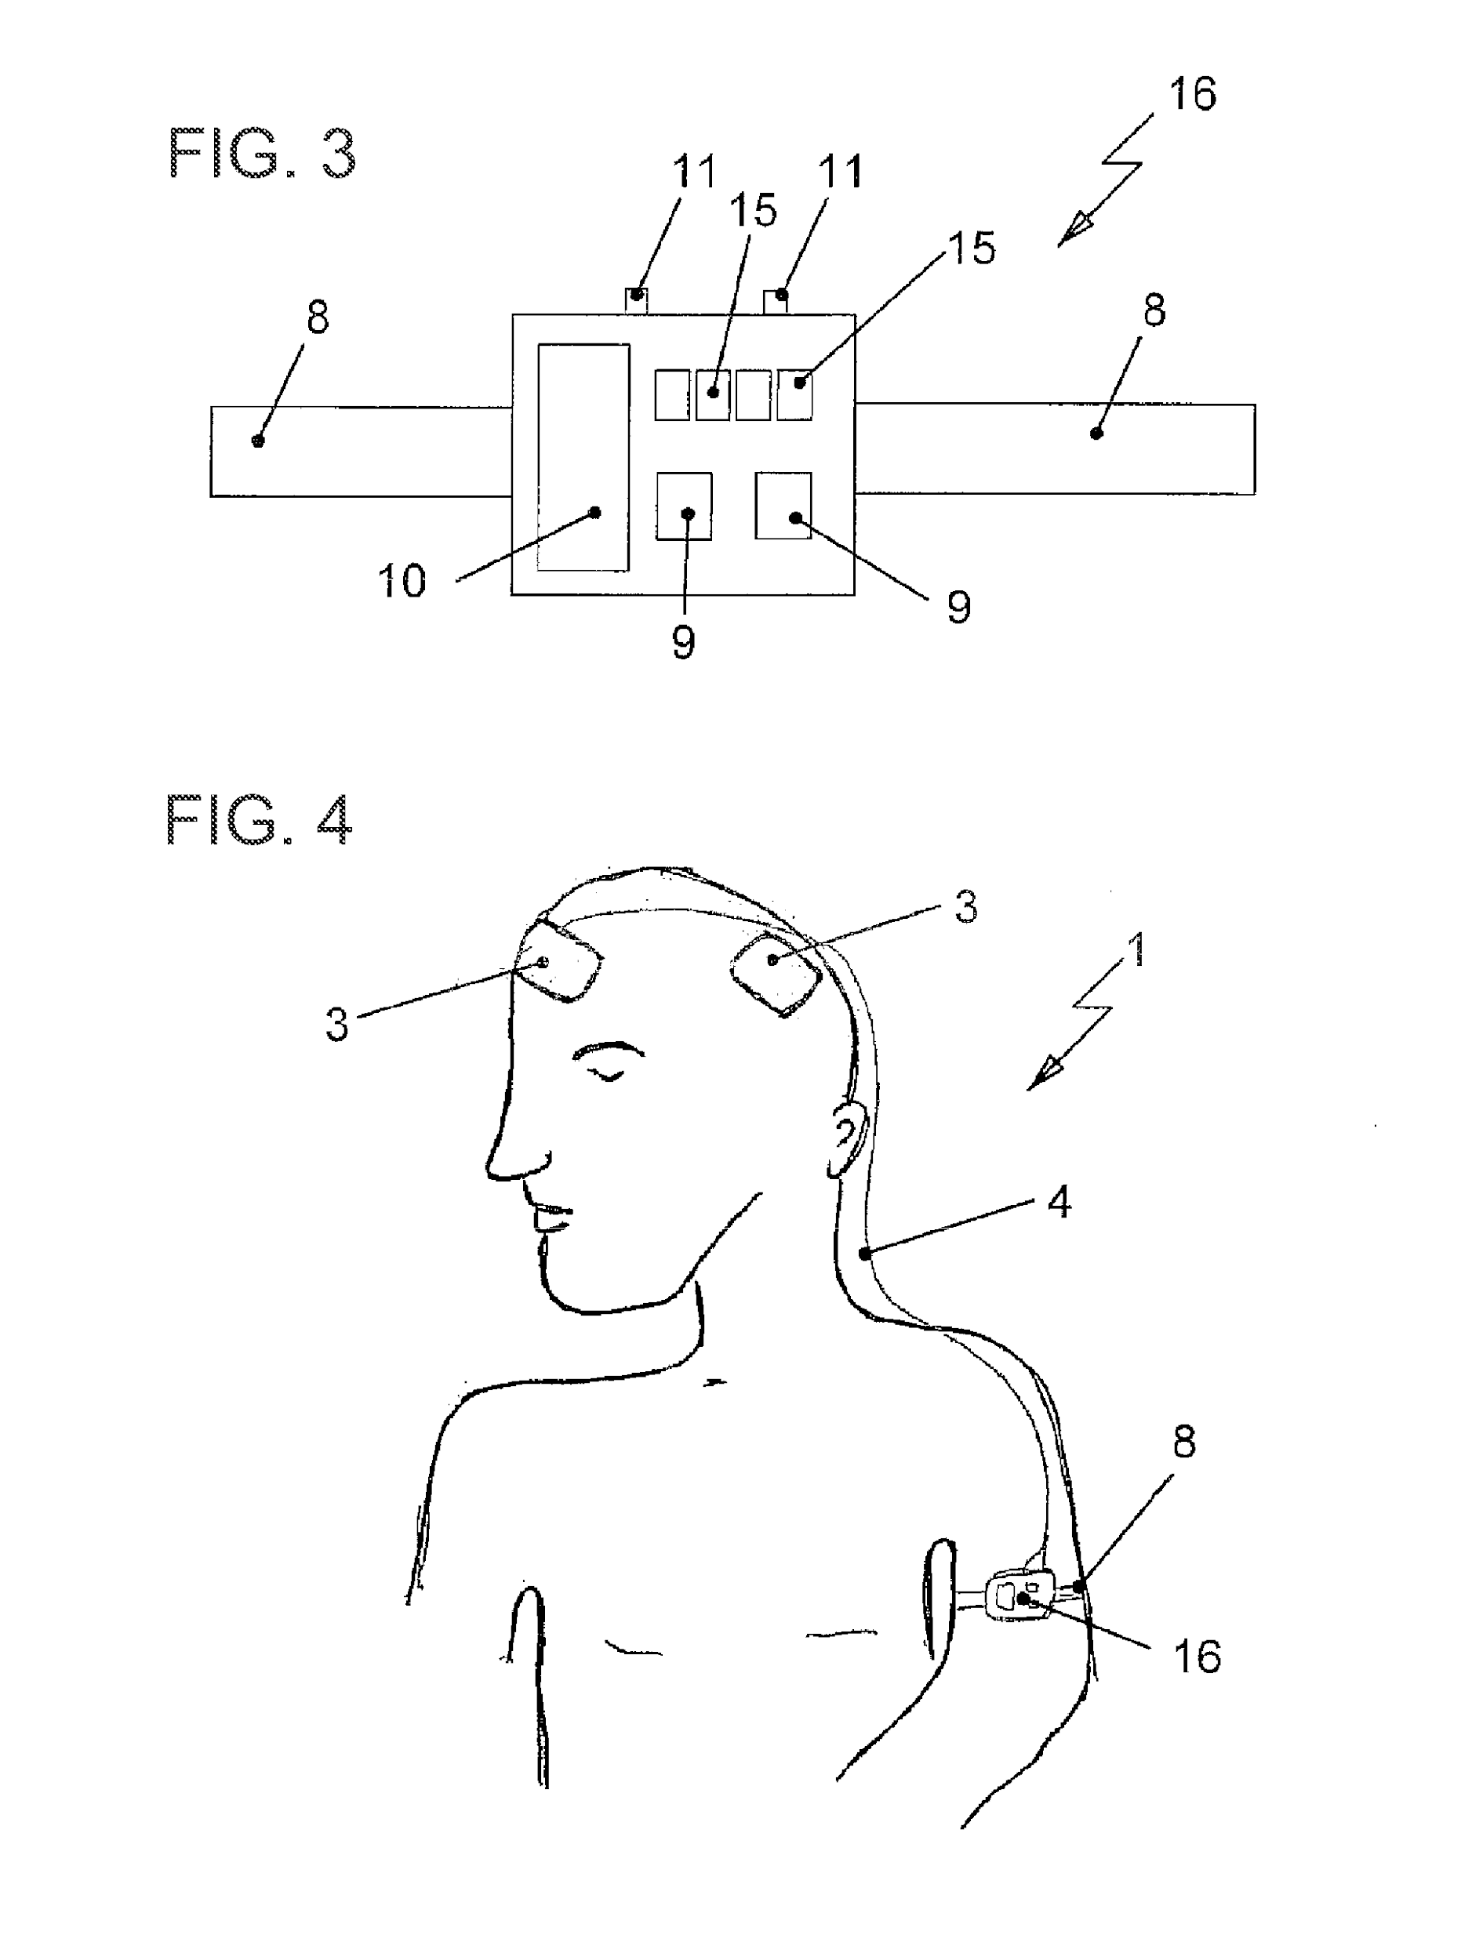
3. **Patent Number: US8239030B1** 
   1. This device utilizes a full headgear design, it is not cost effective however the design is flexible and could be used to design similarly disposable tdcs devices.
   2. 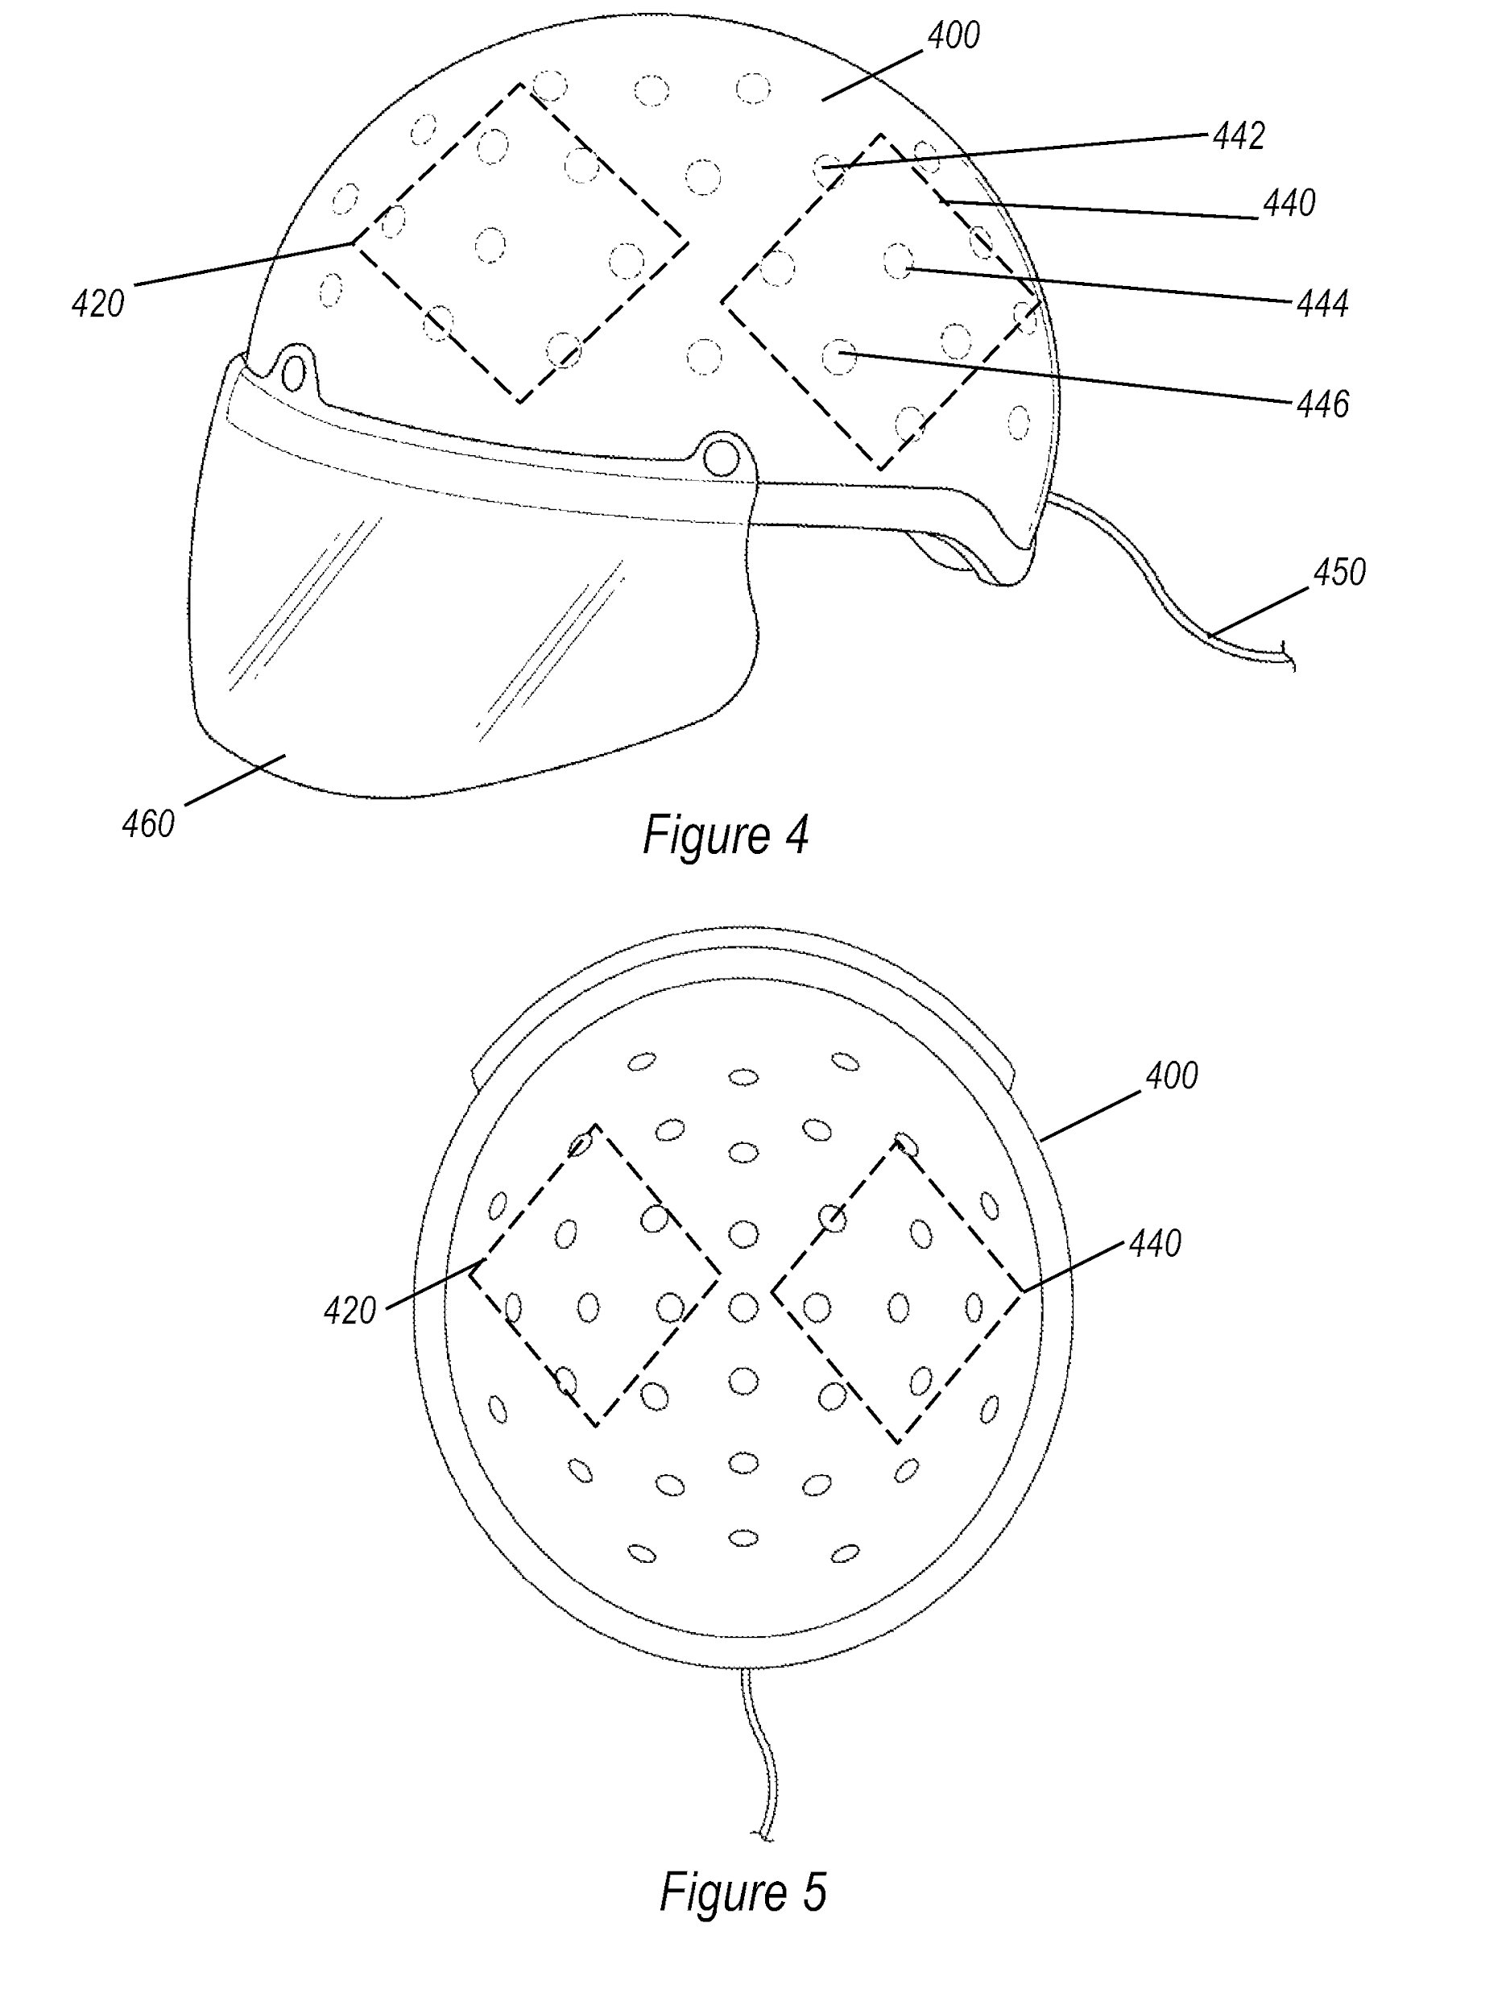
4. **Patent number: US20140148872A1**
   1. Wearable device, it can be self-contained in electrode pads.this is a very good device for hairless skin. It is not disposable and can be complex to use out of the box, has a wide feature set for what is needed. However pad placement is up to the user and makes usability worse
   2. 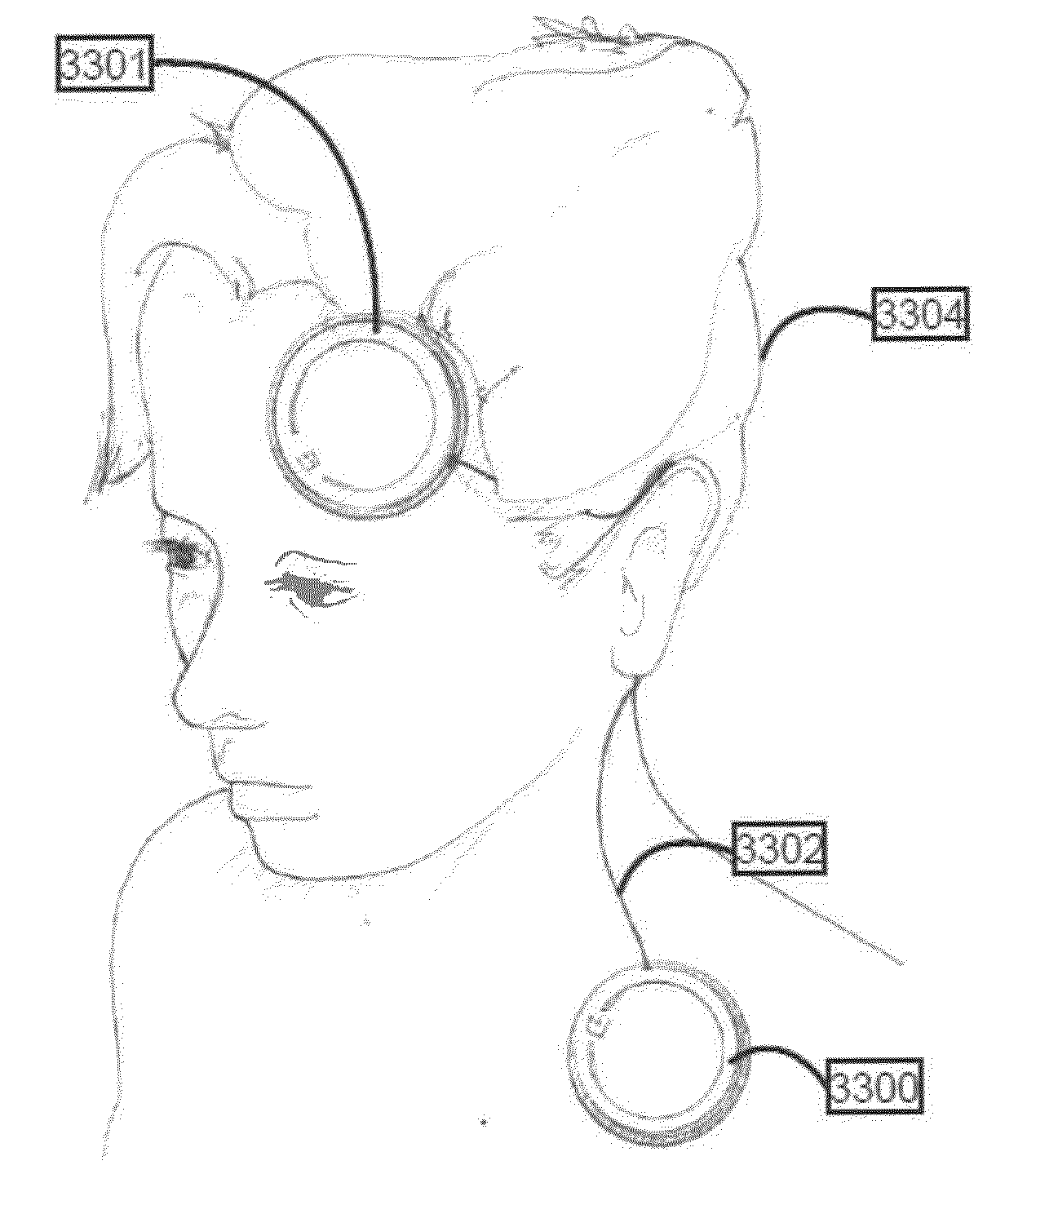
5. **Patent Number: US20130204315A1**
   1. This is a non-invasive device used to treat patients with Tinnitus.
   2. It is a self-administered device, thus can be used without a therapist present.
   3. The device has a primary and secondary electrode that ensure the stimulation is performed at the right position on the scalp.

